**R Code for Examples in the book**

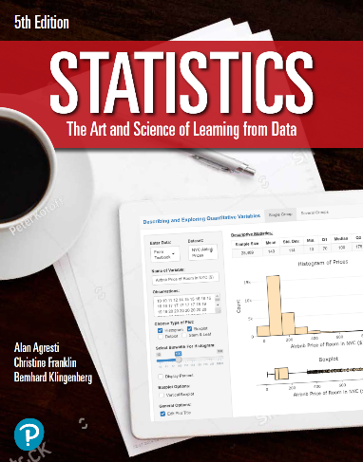

***“Statistics: The Art and Science of Learning from Data”***

**by Agresti, Franklin and Klingenberg, 5th edition**

**Chapter 13**

**Example 12: Travel Credit Cards – Logistic Regression Model**

## Reading in data

creditCards <- read.csv(file='https://raw.githubusercontent.com/artofstat/data/master/Chapter13/credit_card_and_income.csv')  
colnames(creditCards) # check column names

## [1] "adult" "income" "y"

## Fitting in logistic regression model

logitReg <- glm(y ~ income, data = creditCards, family = 'binomial')

## To view a summary of the logistic regression model

summary(logitReg)

##   
## Call:  
## glm(formula = y ~ income, family = "binomial", data = creditCards)  
##   
## Deviance Residuals:   
## Min 1Q Median 3Q Max   
## -1.8164 -0.6611 -0.5190 0.3425 2.0805   
##   
## Coefficients:  
## Estimate Std. Error z value Pr(>|z|)   
## (Intercept) -3.51795 0.71029 -4.953 7.31e-07 ***  
## income 0.10541 0.02616 4.030 5.58e-05 ***  
## ---  
## Signif. codes: 0 '***' 0.001 '**' 0.01 '*' 0.05 '.' 0.1 ' ' 1  
##   
## (Dispersion parameter for binomial family taken to be 1)  
##   
## Null deviance: 123.820 on 99 degrees of freedom  
## Residual deviance: 97.226 on 98 degrees of freedom  
## AIC: 101.23  
##   
## Number of Fisher Scoring iterations: 4

## To estimate the probability that someone with an income of 12000 euros has a travel credit card

predict(logitReg, newdata = data.frame(income=c(12)), type = 'response')

## 1   
## 0.09508757

## and for someone with an income of 65000 euros

predict(logitReg, newdata = data.frame(income=c(65)), type = 'response')

## 1   
## 0.9655647